|  |
| --- |
|  |
| Camel测试管理系统 |
| 亨鑫V1.2 |
|  |
| **XC** |
| **10/23/2012** |

[Type the abstract of the document here. The abstract is typically a short summary of the contents of the document. Type the abstract of the document here. The abstract is typically a short summary of the contents of the document.]

Table of Contents

[To update the table of contents, right click the message below and select Update Field (F9 on PC, ⌥⌘U on Mac).]

**No table of contents entries found.**

1. Pages
   1. Page Tree

Home  
 Page 1  
 Page 2  
 Page 3  
 Page 4  
 Page 5  
 Page 6  
 Production Info  
 PIM  
 Product_test_case

* 1. Home
     1. User Interface

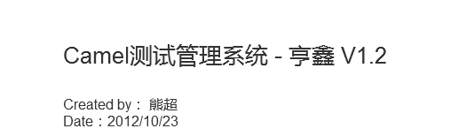

* 1. Page 1
     1. User Interface

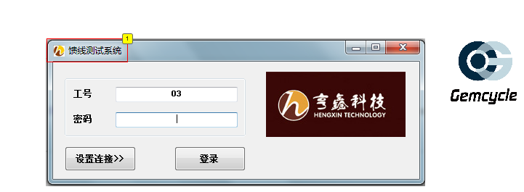

* + 1. Widget Table

|  |  |  |  |
| --- | --- | --- | --- |
| Footnote | Label | Description | Assigned To |
| 1 | Logo和程序名称 | Logo改为：“透明底Gemcycle” 程序名称改为：Camel测试终端 | HC |

* 1. Page 2
     1. User Interface

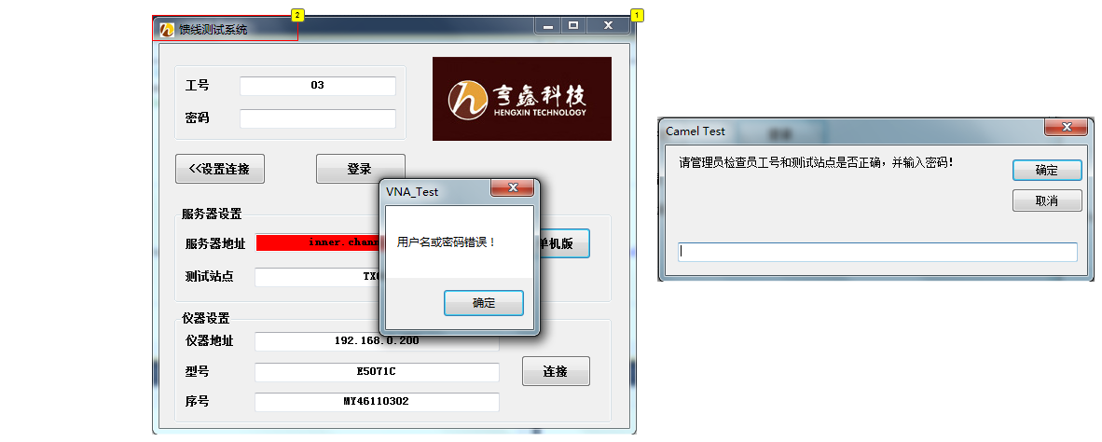

* + 1. Widget Table

|  |  |  |  |
| --- | --- | --- | --- |
| Footnote | Label | Description | Assigned To |
| 1 | 单机版登录逻辑 | 现在情况：尝试登录“单机版”，输入管理员密码错误，提示用户名或密码错误，再次点击“单机版”，依然提示用户名或密码错误。 期望情况：再次点击“单机版”，弹出请管理员输入密码的窗口 | HC |
| 2 | logo和程序名称 | Logo改为：“透明底Gemcycle” 程序名称改为：Camel测试终端 | HC |

* 1. Page 3
     1. User Interface

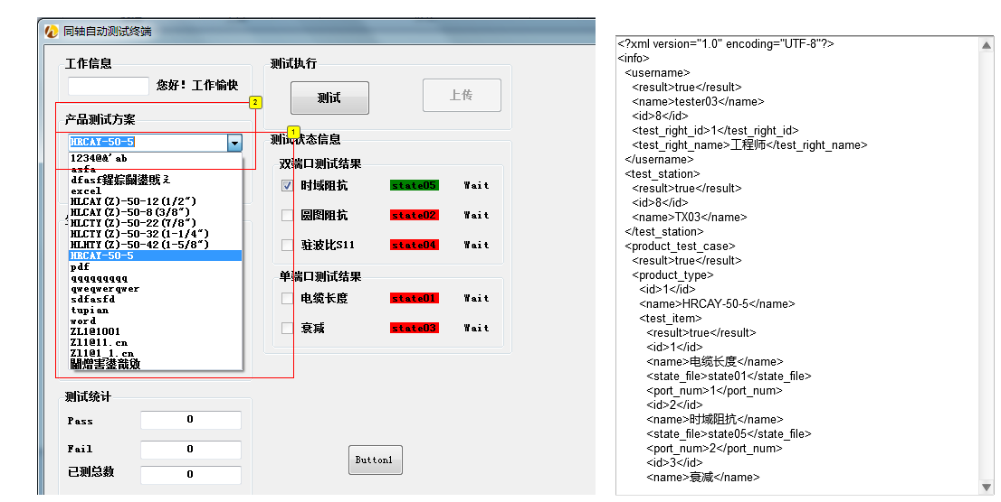

* + 1. Widget Table

|  |  |  |  |
| --- | --- | --- | --- |
| Footnote | Label | Description | Assigned To |
| 1 | 产品测试方案 | 现在情况：下载内容为产品管理列表 期望情况：下载内容为产品测试方案列表，即未定义测试方案的产品信息不返回给测试终端 | Penn |
| 2 | 支持从本地csv文件 | 增加功能通过读取本地的csv文件，加载“产品测试方案”，csv文件从服务器下载。 | HC |

* 1. Page 4
     1. User Interface

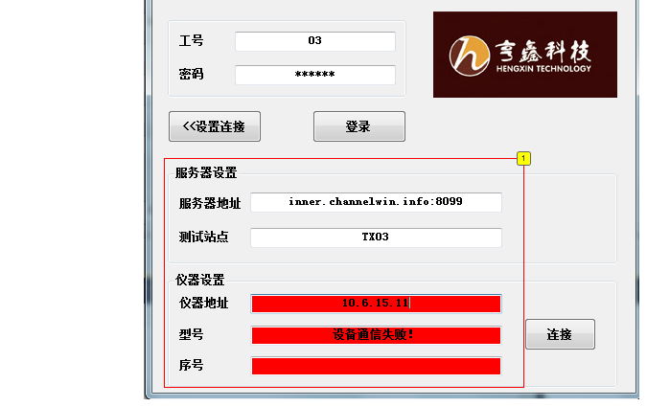

* + 1. Widget Table

|  |  |  |  |
| --- | --- | --- | --- |
| Footnote | Label | Description | Assigned To |
| 1 | 退出保存设置 | 确认退出程序时，服务器设置和仪器设置的信息能够保存。现在测试结果未保存。 | HC |

* 1. Page 5
     1. User Interface

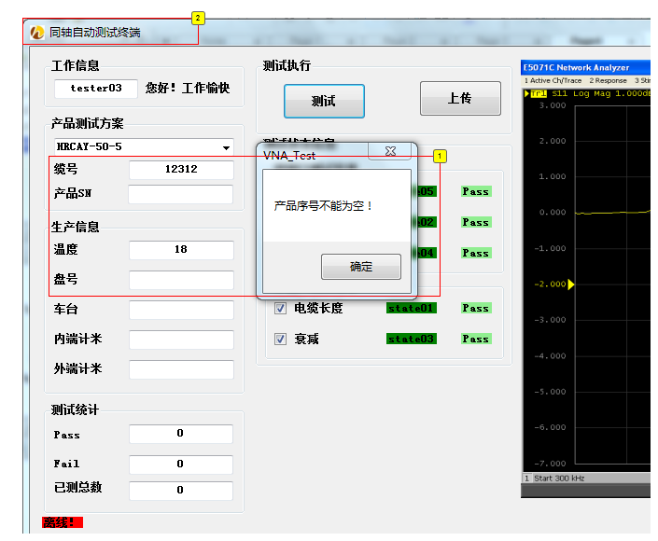

* + 1. Widget Table

|  |  |  |  |
| --- | --- | --- | --- |
| Footnote | Label | Description | Assigned To |
| 1 | 缆号或产品SN不能为空 | 缆号或产品SN不能为空 | HC |
| 2 | Logo和程序名称 | Logo改为：“透明底Gemcycle” 程序名称改为：Camel测试终端 | HC |

* 1. Page 6
     1. User Interface

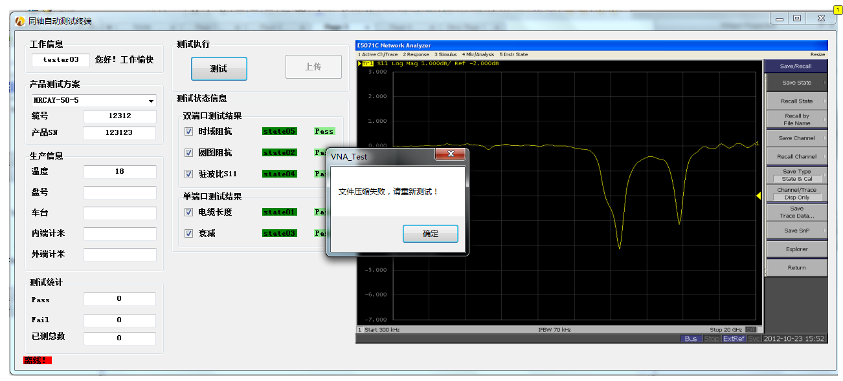

* + 1. Widget Table

|  |  |  |  |
| --- | --- | --- | --- |
| Footnote | Label | Description | Assigned To |
| 1 | 文件压缩失败 | 测试机器上装了WinRAR，什么原因？ | HC |

* 1. Production Info
     1. User Interface

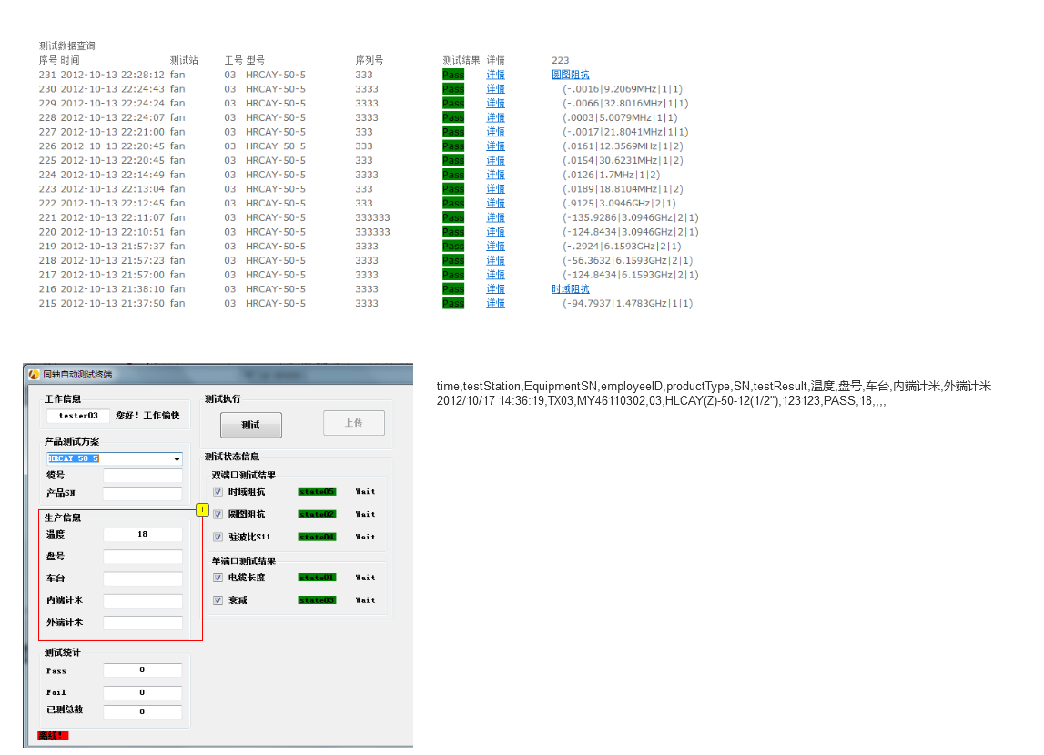

* + 1. Widget Table

|  |  |  |
| --- | --- | --- |
| Footnote | Label | Assigned To |
| 1 | 生产信息如何记录，并供查询 | Penn |

* 1. PIM
     1. User Interface

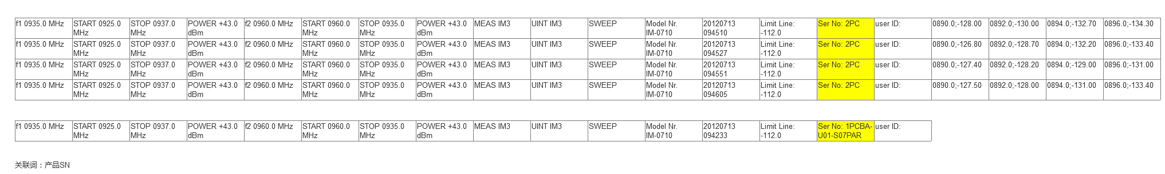

* 1. Product_test_case
     1. User Interface

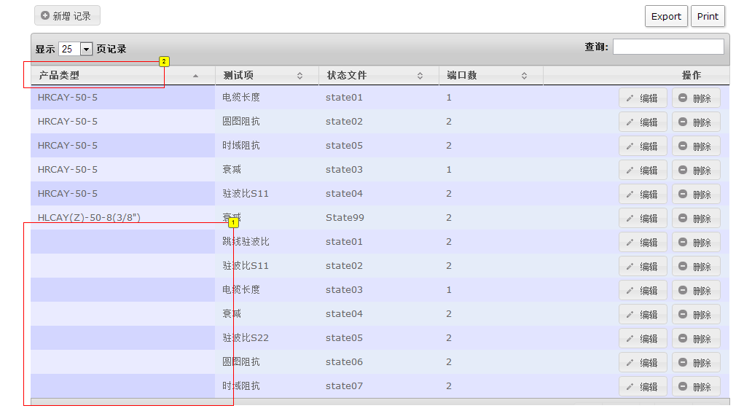

* + 1. Widget Table

|  |  |  |  |
| --- | --- | --- | --- |
| Footnote | Label | Description | Assigned To |
| 1 | 产品类型不能为空 | 产品类型不能为空 | Penn |
| 2 | 改为“产品型号” | 改为“产品型号” | Penn |